Project Design Phase-II
Technology Stack (Architecture & Stack)

Date | 16 June 2025
Team ID | LTVIP2025TMID59367
Project Name | orderonthego: your on-demand food ordering solution
Maximum Marks | 4 Marks

Technical Architecture:
The Deliverable shall include the architectural diagram as below and the information as per the table1 & table 2
Example: Order processing during pandemics for offline mode
Reference: https://developer.ibm.com/patterns/ai-powered-backend-system-for-order-processing-during-pandemics/

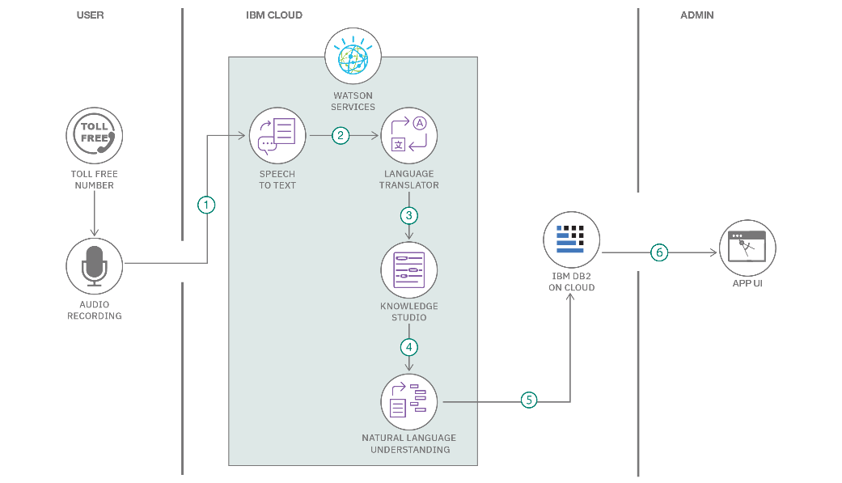

Table
-
:
: Components & Technologies
1

S.No

Component

Description

Technology

Guidelines:

Include all the processe
s (As an application logic /
Technology Block)

Provide infrastructural demarcation (Local / Cloud)

Indicate external interfaces (third party API’s etc.)

Indicate Data Storage components / services

Indicate interface to machine learning models (if
applicable)

1. | User Interface | Web UI for user interaction | HTML, CSS, React.js, Tailwind CSS.
2. | Application Logic-1 | Customer-side logic (e.g., menu browsing, cart, orders) | JavaScript (React.js), Axios
3. | Application Logic-2 | Backend logic for authentication and food operations | Node.js, Express.js
4. | Application Logic-3 | Admin & Restaurant logic (approvals, menu control, etc.) | Node.js, Express.js
5. | Database | Stores all app data | MongoDB (Mongoose ODM)
6. | Cloud Database | Hosted on cloud | MongoDB Atlas
7. | File Storage | Image hosting (restaurant images, product images) | Cloudinary (or local for dev)
8. | External API-1 | Weather or geo-location API (optional for extensions) | Not used currently / OpenWeather API
9. | External API-2 | Payment gateway (for future use) | Razorpay / Stripe (future integration)
10. | Machine Learning Model | Not implemented in CraveKart Foods | N/A
11. | Infrastructure (Server / Cloud) | Server deployment | Render / Railway (for hosting) or Vercel  (frontend)
S.No | Characteristics | Description | Technology
1. | Open-Source Frameworks | Frameworks used in client & server | React.js, Express.js, MongoDB, Node.js
2. | Security Implementations | JWT auth, bcrypt hashing, CORS, rate limits. | bcrypt, JWT, CORS
3. | Scalable Architecture | Separation of client/server, RESTful APIs, MongoDB Atlas for scaling | MERN Stack with REST APIs
4. | Availability | Deployed on cloud platforms with high uptime (Vercel/Render/Railway) | Cloud hosting + MongoDB Atlas

Table-2: Application Characteristics:
S.No | Characteristics | Description | Technology
5. | Performance | React-based UI with lazy loading, API pagination, CDN usage (Vercel/CDN) | React, Axios, MongoDB Indexes

References:
https://www.mongodb.com/mern-stack https://www.mongodb.com/atlas/database https://expressjs.com/ https://reactjs.org/ https://jwt.io/introduction/

